**COLLEGE ATTENDANCE SYSTEM**

**USING FACIAL-IMAGE RECOGNITION**

**AND DEEP LEARNING**

A MINI-PROJECT REPORT

***By***

**Carol Sebastian (8320)**

**Surya Pratap Shahi (8367)**

**Kevin Cheruthuruthy (8321)**

*Under the guidance of*

**Prof. Dipali Koshti**



DEPARTMENT OF COMPUTER ENGINEERING

FR. CONCEICAO RODRIGUES COLLEGE OF ENGINEERING

FR. AGNEL ASHRAM, BANDRA (W),

MUMBAI - 400 050.

**UNIVERSITY OF MUMBAI**

**(2019 – 2020)**

**FR. CONCEICAO RODRIGUES COLLEGE OF ENGINEERING**

**FR. AGNEL ASHRAM, BANDRA (W),**

**MUMBAI - 400 050**.



**CERTIFICATE**

This is to certify that the following students working on the project“COLLEGE ATTENDANCE SYSTEM

USING FACIAL-IMAGE RECOGNITION”

have satisfactorily completed the requirements of the project in fulfillment of the course T.E in Computer Engineering of the University of Mumbai during academic year 2019-2020 under the guidance of “Prof. **Dipali Koshti**”.

**Submitted By**

**Carol Sebastian (8320)**

**Surya Pratap Shahi (8367)**

**Kevin Cheruthuruthy (8321)**

|  |  |
| --- | --- |
| **Prof.Dipali Koshti**  **Guide** | **Dr. B.S.Daga**  **Head of the Department** |

**________**

**Principal**

**CERTIFICATE**

This is to certify that the project synopsis entitled

**“COLLEGE ATTENDANCE SYSTEM**

**USING FACIAL-IMAGE RECOGNITION”**

submittedby the following students is found to be satisfactory and the report has been approved as it satisfies the academic requirements in respect of mini-project work prescribed for the course.

**NAME**

**Carol Sebastian**

**Surya Pratap Shahi**

**Kevin Cheruthuruthy**

|  |  |
| --- | --- |
| **Internal Examiner**  (Signature)  Name:  Date: | **External Examiner**  (Signature)  Name:  Date: |

**Seal of the Institute**

**DECLARATION OF THE STUDENT**

We declare that this written submission represents our ideas in our own words and where others' ideas or words have been included, we have adequately cited and referenced the original sources.

We also declare that we have adhered to all principles of academic honesty and integrity and have not misrepresented or fabricated or falsified any idea / data / fact / source in my submission.

We understand that any violation of the above will be cause for disciplinary action by the Institute and can also evoke penal action from the sources which have thus not been properly cited or from whom proper permission has not been taken when needed.

Signature of the student **Date:**

Carol Sebastian

(8320**)**

Signature of the student **Date:**

Surya Pratap Shahi

(8367**)**

Signature of the student **Date:**

Kevin Cheruthuruthy

(8321)

**ACKNOWLEDGEMENT**

**ABSTRACT**

**Introduction**

**Tracking and monitoring attendance of students is a vital aspect for any educational institute.  Attendance is the main tool to monitor the punctuality of employees or students in any organization. Although Traditional attendance methods such as roll calling or record book based attendance are out of date and time consuming. Traditional attendance system is susceptible to proxies and mistakes. Therefore we present “COLLEGE ATTENDANCE SYSTEM USING FACIAL-IMAGE RECOGNITION AND DEEP LEARNING” which uses human facial presence and unique characteristics of the Face of the Student in the classroom at real-time to ensure accuracy; prevent errors, and proxy attendance.**

**Problem Statement**

**To create an application that which uses human facial presence and unique characteristics of the Face of the Student in the classroom at real-time and in reference to prior mentioned name-labels associated to the recognized faces in the database, mark the attendance of the student.**

**Table of Contents**

Chapter 1: Introduction**........................................................................................................ 3**

Chapter 2: Literature Review**................................................................................................ 4**

Chapter 3: Proposed System**.................................................................................................. 6**

3.1: Problem statement Analysis**............................................................................. 7**

3.2: Design of proposed system**.............................................................................. 8**

3.3: Algorithm**......................................................................................................... 9**

3.4: Methodology**.................................................................................................... 11**

3.5: Façade Pattern**.................................................................................................. 12**

3.6: Risk Table**......................................................................................................... 13**

Chapter 4: Hardware software requirements and Implementation**......................................... 14**

4.1: Results**.............................................................................................................. 15**

4.2: Conclusion**........................................................................................................ 18**

Chapter 5: Appendix / Appendices**......................................................................................... 19**

Chapter 6: References(IEEE Format**)..................................................................................... 20**

**Chapter 1 - Introduction**

**Tracking and monitoring attendance of students is a vital aspect for any educational institute.  Attendance is the main tool to monitor the punctuality of the employees or students in any organization. Although Traditional attendance methods such as roll calling or record book based attendance are out of date and time consuming. Traditional attendance system is susceptible to proxies and mistakes. Therefore we present “COLLEGE ATTENDANCE SYSTEM USING FACIAL-IMAGE RECOGNITION” which uses human facial presence and unique characteristics of the Face of the Student in the classroom at real-time, to ensure accuracy, prevent errors, and proxy attendance.**

**The Aim of the Project**

**The application aims to take information from college database which includes pictures of all students and detects their presence in the class after the teacher clicks a picture and updates the attendance of students present in the class automatically for the lecture in the records.**

**The Scope of the System**

**The Application can be easily implemented by a series of registration and implementation technique with all the altering rights advocated only to the admin panel of the Institution (Principal/HODs). This application can be easily implemented in any college and the requirements are the application and a Smartphone.**

**Rectifications to Traditional Model**

**Teachers do not require complex technical knowledge to use the system and can be completed with minimal training. Additional benefits for students and educational institutes include accurate attendance without Proxy attendance and mistakes which are common problems faced in using traditional attendance marking methods. The system Saves time as it avoids the need to maintain books and marking attendance manually and hence saves a lot of time of teachers in writing entries and rectifying attendance data errors faced in traditional methods.**

**The proposed System Increases Efficiency as, they not only eliminate mistakes related to tracking attendance data but also speed up data authentication which reduces administration time and creates efficiency. This project also acts as an advancement in Security and privacy as the application captures the image of the students present in the class converts it to computer code and stores the information in a database making it impossible to duplicate the original image for fraud purposes for later verification and validation of a particular employee or student.**

**Page 3**

**Chapter 2 – Review of Literature**

**Face recognition has the capacity to become an invaluable part of many identification systems used for evaluating the performance of those people functioning within the organization. Biometric technologies are being appertained in many fields which is not yet delivered, its assure of guaranteeing automatic human recognition. Face recognition is a technique of biometric recognition.**

**The Earlier Methods used for the implementation of the project have authors who used the Eigenface approach for face recognition which was introduced by Kirby and Sirovich in 1988 at Brown University. The method works by analyzing face images and computing Eigenface which are faces composed of eigenvectors. The comparison of Eigenface is used to identify the presence of a face and its identity. There is a five step process involved with the system developed by Turk and Pentland. Further on there were methods such as the PCA method has been widely used in applications such as face recognition and image compression.[ Nirmalya Kar, Mrinal Kanti Debbarma, Ashim Saha, and Dwijen Rudra Pal 2012]. PCA is a common technique for finding patterns in data, and expressing the data as eigenvector to highlight the similarities and differences between different data.**

**The function implementation is done in four steps:**

1. **Load the training data.**
2. **Do PCA on it to find a subspace.**
3. **Project the training faces onto the PCA subspace.**
4. **Save all the training information.**
5. **Eigenvalues**
6. **Eigenvectors**
7. **The average training face image**
8. **Projected face image**
9. **Person ID number**

**There are few commercial solutions available to companies, that implement face recognition in work environments. Kawaguchi [Balcoh, Naveed Khan, M. Haroon Yousaf, Waqar Ahmad, and M. Iram Baig,2012] proposes face recognition in attendance management systems. This system aims to detect the position of each student and capture an image for that student, which is later identified. The systems that use biometrics such as iris recognition, fingerprint recognition, etc. to identify users are being used in many institutions [Saraswat, Chitresh, and Amit Kumar,2010]. However, these require a lot of financial input. It would also require from the university to record biometric information from all students, which would introduce further privacy concerns. These systems are also subject to physical damage from their users. Therefore, they need additional**

**maintenance costs [Patel, Unnati A., and S. Priya,2014]. The idea proposed by us, removes physical access from anyone to the system.**

**Page 4**

**The other proposed system for the process of face detection is Viola Jones algorithm which makes it a good detection algorithm are:**

* **Robust –high detection rate (true-positive rate) & low false-positive rate**
* **Real time – Processing must be at least 2 times/sec for practical applications.**

**The goal is to differentiate faces from non-faces as face detection is the first step in the identification process. The algorithm has mainly four main stages:**

* **Haar Features Selection**
* **Creating Integral image**
* **Adaboost Training algorithm**
* **Cascaded Classifiers**

**To capture image regular camera application (desktop based) was developed using python. As we have 3 different camera presents in the classroom so, we would extract the face from each image. If there is a presence of 2 faces of the same person one would get discarded. The image was captured using traditional CV2(Computer Vision) package in python [Turk, Matthew, and Alex Pentland,1991].**

**The System for Face recognition that followed is The HOG descriptor suited for human detection in images. [ Aman Jobanputra, Shubham Jain, Kruttika Choithani 2016 ] The essential thought behind the Histogram of Oriented Gradient descriptors is that local object appearance and shape within an image can be described by the distribution of intensity gradients or edge directions. The implementation of these descriptors can be achieved by dividing the image into small connected regions, called cells, and for each cell compiling a histogram of gradient directions or edge orientations for the pixels within the cell. The combination of these histograms then represents the descriptor.**

**Error-Correcting Output Coding (ECOC) is an ensemble method designed for multi-class classification problem. In multi-class classification problem, the task is the decision of one label from k > 2 possible choices. ECOC is a meta method which combines many binary classifiers in order to solve the multi-class problem. It uses the SVM (Support Vector Machine) binary classifier. In machine learning, support vector machines (SVMs, also support vector networks) are supervised learning models with associated learning algorithms that analyze data and recognize patterns, used for classification and regression analysisAn SVM model is a representation of the examples as points in space, mapped so that the examples of the separate categories are divided by a clear gap that is as wide as possible. New examples are thereafter mapped into that same space and then predicted to belong to a category based on which side of the gap they fall on.**

**Page 5**

**Chapter 3 – Proposed System**

**Teachers do not require complex technical knowledge to use the system and can be completed with minimal training. Additional benefits for students and educational institutes include accurate attendance without Proxy attendance and mistakes which are common problems faced in using traditional attendance marking methods. The system Saves time as it avoids the need to maintain books and marking attendance manually and hence saves a lot of time of teachers in writing entries and rectifying attendance data errors faced in traditional methods.**

**The goal is to differentiate faces from non-faces as face detection is the first step in the identification process. The algorithm has mainly four main stages:**

* **Haar Features Selection**
* **Creating Integral image**
* **Adaboost Training algorithm**
* **Cascaded Classifiers**

**To capture image regular camera application (desktop based) was developed using python. As we have 3 different camera presents in the classroom so, we would extract the face from each image. If there is a presence of 2 faces of the same person one would get discarded. The image was captured using traditional CV2(Computer Vision) package in python [Turk, Matthew, and Alex Pentland,1991].**

**The proposed System Increases Efficiency as, they not only eliminate mistakes related to tracking attendance data but also speed up data authentication which reduces administration time and creates efficiency. This project also acts as an advancement in Security and privacy as the application captures the image of the students present in the class converts it to computer code and stores the information in a database making it impossible to duplicate the original image for fraud purposes for later verification and validation of a particular employee or student.**

**Page 6**

**Chapter 3.1 – Proposed System Analysis**

* **Time Usage – The proposed System takes as much time as the teacher will take to click a picture and in less than a minute (considering all the work behind), all the students will get their attendance notification.**
* **Efficiency – The proposed system eliminates the human error by the teacher as well as by students while attendance is being taken and thus has a better efficiency than the current system in institutes.**
* **Accessiblity – The students can easily keep a track of their attendance using the android app which gives the details on each person’s profile. The teachers can also keep students’ parents notified with just a simple click and hence reducing their work.**
* **System Manipulation – Unlike the current system where students easily mark fake attendances / proxies, in the proposed system this is not possible as the student will have to be present inside the class picture to mark his/her attendance and hence manipulation of the system is not possible at all.**
* **Overall – Considering all the above mentioned aspects, we consider our system as an upgrade to the current system which will definitely function in a much faster, efficient and authentic way of taking attendance in educational institutions.**

**Page 7**

**Chapter 3.2 – Proposed System Design**

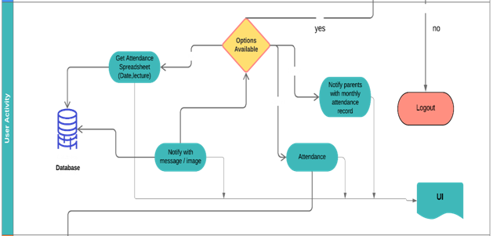

**Page 8**

**Chapter 3.3 – Algorithms**

**what we actually want to achieve, is to identify a person given an image of his / her face, e.g. the input image. The way we do that, is to provide one (or more) image(s) for each person we want to recognize, labeled with the persons name, e.g. the reference data. Now we compare the input image to the reference data and find the most similar reference image. If both images are similar enough we output the person’s name, otherwise we output ‘unknown’.**

**However, two problems remain. Firstly, what if we have an image showing multiple persons and we want to recognize all of them? And secondly, we need to be able to obtain such kind of a similarity metric for two face images in order to compare them…**

**Face Detection**

**The answer to the first problem is face detection. Simply put, we will first locate all the faces in the input image. Face-api.js implements multiple face detectors for different usecases.**

**The most accurate face detector is a SSD (Single Shot Multibox Detector), which is basically a CNN based on MobileNet V1, with some additional box prediction layers stacked on top of the network.**

**Furthmore, face-api.js implements an optimized Tiny Face Detector, basically an even tinier version of Tiny Yolo v2 utilizing depthwise seperable convolutions instead of regular convolutions, which is a much faster, but slightly less accurate face detector compared to SSD MobileNet V1.**

**Lastly, there is also a MTCNN (Multi-task Cascaded Convolutional Neural Network) implementation, which is mostly around nowadays for experimental purposes however.**

**The networks return the bounding boxes of each face, with their corresponding scores, e.g. the probability of each bounding box showing a face. The scores are used to filter the bounding boxes, as it might be that an image does not contain any face at all. Note, that face detection should also be performed even if there is only one person in order to retrieve the bounding box.**

**Page 9**

**Chapter 3.4 – Methodology**

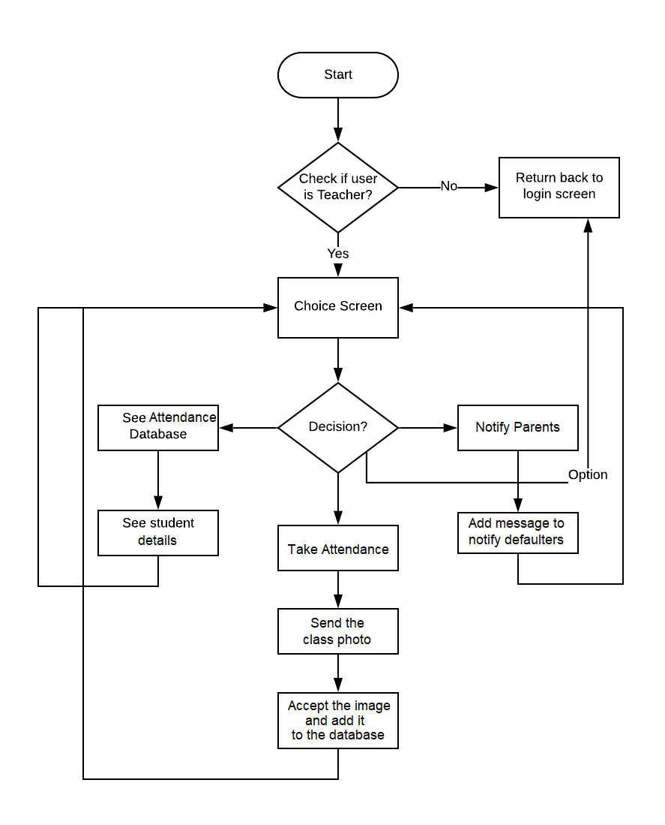

**Page 11**

**Chapter 3.5. – Façade Pattern**

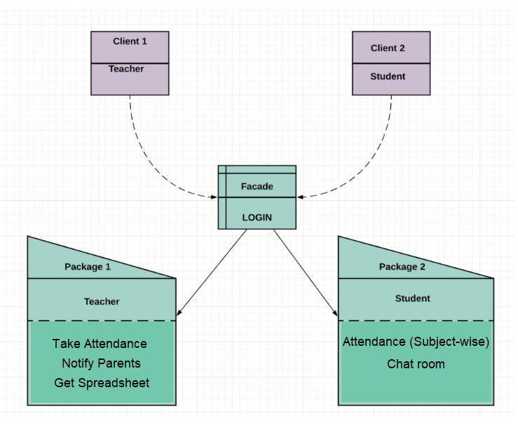

**Page 12**

**Chapter 3.6 - Risk Table**

|  |  |  |  |  |  |
| --- | --- | --- | --- | --- | --- |
| Sr.No | Description | Probability | Type | Severity | Mitigation Strategy |
| 1 | Database is Not Updated With Respect to Details for Communication | 40% | Requirements Risk | **Critical** | Keep One to One Interaction Directly linking Data to the Database thus ensuring appropriate link of Peer to Parents |
| 2 | Staff is inexperienced to understand working of program | 30% | Learning Curve Risk | **Marginal** | Expose the staff to runs of the program. Make them aware of the functioning of the entire system. |
| 3 | Lead programmer or Office Administrator decides to quit | 36% | Key Personnel Risk | **Catastrophic** | Have a set of employees training under the lead programmer. Make sure everyone remains in the loop and is aware of what other people in the team have worked on. |
| 4 | Size estimation of code required was incorrect. | 49% | Schedule Risk | **Critical** | Have a contingency team ready to punch in the hours required to get the job done. Size estimated should be always divided into worst case, best case and average case conditions. Choose worst case scenario to avoid maximum loss. |
| 5 | Face Detected was exposed to multiple similar faces in best case TWIN SIBLINGS or exposed to facial masks | 60% | Requirements Risk | **Critical** | Make sure you treat the differences in twin siblings such that there is appropriate way to distinguish and update the data. Also understand the shape dissimilarities in case of a mask and take appropriate steps to identify it |

Conclusion

The appropriate list of Risks for the particular software is appropriately identified and the mitigation practices are put in place with the help of a Efficient Risk Table that needs to be followed by the team.

**Page 13**

**Chapter 4 - Software and Hardware Requirements**

***Users and Characteristics***

1. **Students**

**Students can check their attendance status anytime they want and also give feedback to the teachers directly from the app.**

1. **Teachers**

**The app will allow teachers to take picture of the class and using deep learning algorithm will mark the attendance of all present students directly from the app in seconds.**

***Operating Environment***

1. **Android and IOS app : Flutter and Dart**
2. **Web App: HTML, CSS, Javascript**
3. **Back-end: Firebase and Nodejs**
4. **Core function: Deep Learning(face.api)**

***Design and Implementation Constraints***

* **Android App: Must not have older android version.**
* **Web app: A basic webpage and won’t require any technical knowledge**

***User Documentation***

* **The app and the web page are simple enough to operate by anyone without any documentation.**

***Assumptions and Dependencies***

1. **1. College Database Connection:**
2. **A database of students will be needed to add their attendance and provide a excel sheet of the record.**
3. **2. Teacher timetable:**
4. **The name and class of all subjects taught by all the teachers of the college will be needed so as to implement the app in the whole college.**

***Hardware Interfaces***

**Nohardware interfaces required.**

***Software Interfaces***

**Camera Application is needed in a device with active Internet Connection.**

***Communications Interfaces***

**The Android App will be the most convenient source.**

**Page 14**

**Chapter 4.1 - Results**

**Android/IOS Application**

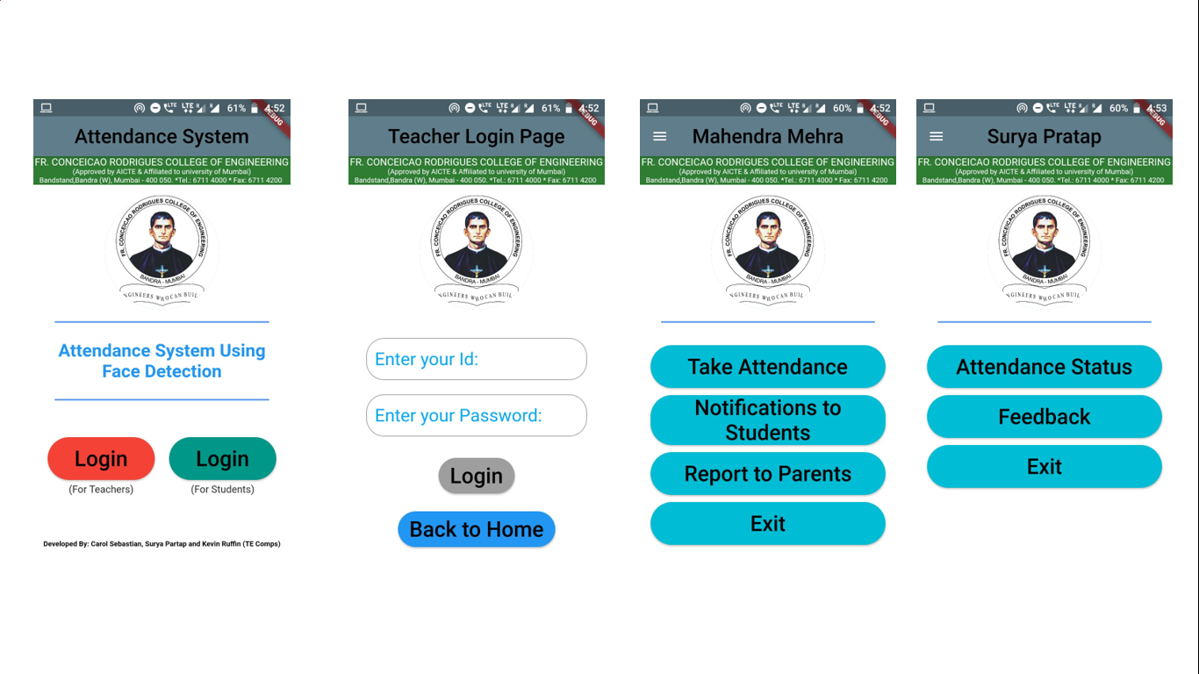

**Notifications**

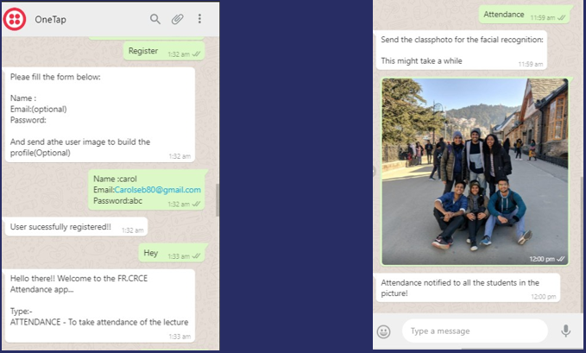

**Page 17**

**Chapter 4.2 - Conclusion**

**COLLEGE ATTENDANCE SYSTEM USING FACIAL-IMAGE RECOGNITION AND DEEP LEARNING demonstrates real time attendance marking and management. This is an active example of the application which not only helps the teacher to take attendance but also carry out the tasks of notifying parents/guardians of the presence of their children during the lecture, provides essential database secure record of the attendance taken, and also to check the total attendance of the students.**

**All these activities require appropriate and authentic sources of information and that particular information must be referenced or cited according to the guidelines. Therefore while implementation it is necessary to have a standard, appropriate and uniform form of database available for the operation of the system.**

**The following database that we have is a photo database from scratch with the help of the students in our class. The Facial recognition database can be improved by adding better images and variable poses if required of the students to make recognition full proof. The Web based architecture and the Application based architecture can be utilized further by maintaining the databases on a remote server and the Application will be accessible via the Internet.**

**It is important to identify the correct tools to use in commercial and scientific studies for the purpose of the aim which this project satisfies. Barcode readers, Radio Frequency Identification (RFID) system, Bluetooth and NFC (Near Field Communication) are just a few of the examples of such tools. However, they are expensive and therefore they had limited use. Hence a system which does not require these special infrastructure or requirements is developed using this project**

**The proposed system is user friendly and does not require much technical knowledge in terms of training and usage of the application. The reason is that the maximum job is done by the application in itself and only requires the single input (In this case a Photograph of the Class) and the retrieval and storing of this data is fast and the maintenance of the data is efficiently. Defaulter Reports can be generated very comfortably in the proposed system so that user can generate the report as per his/her requirement (monthly) or in the middle of the session.**

**Page 18**

**Chapter 5- Appendix**

* **Face.api**

**Deep Learning model which is used in face detection process.**

* **Flutter and Dart**

**Framework and Language used to the creation of Android App.**

* **HTML, CCS, Javascript**

**Languages used to make the Web app.**

* **Firebase and NodeJS**

**Used to backend of Android app and web app.**

**Page 19**

**Chapter 6- References**

1. ***Image-based Face Detection and Recognition***

**Faizan Ahmad, Aaima Najam and Zeeshan Ahmed University of Beijing**

**International Journal of Computer Science Issues (IJCSI).**

**2013**

1. ***Study of Implementing Automated Attendance System Using Face Recognition Technique***

**Nirmalya Kar, Mrinal Kanti Debbarma, Ashim Saha, Dwijen Rudra Pal**

**International Journal of Computer & Communication Engineering, Vol. 1**

**July 2012**

1. ***Automatic Attendance Management System Using Face Recognition***

**Swapna Munigala; Samiha Mirza; Zeba Naseem Fathima; Zubaira M.**

**CSE Department, Stanley College of Eng. & Technology for Women**

**IJCSN - International Journal of Computer Science and Network,**

**April 2019**

1. ***Face Detection and Recognition for Automatic Attendance system***

**Amulya S, Nisarga , Pilli Siva Gowtham Reddy,Dr. Hariprasad S ,Sunil M**

**Jain University,Bangalore, India.**

**International Education & Research Journal [IERJ]**

**2018**

1. ***Smart Attendance Management System***

**Aman Jobanputra, Shubham Jain, Kruttika Choithani**

**Department Of Information Technology Thadomal Shahani Eng. College**

**International Journal of Computer Science Trends and Technology (IJCST) Sep - Oct 2016**

1. ***Automatic Attendance System Using Deep Learning***

**Sunil Aryal, Rachhpal Singh, Arnav Sood, Gaurav Thapa**

**International Conference on Sustainable Computing in Science, Technology & Management**

**SUSCOM-2019**

**Page 20**